Laboratory 3

ITT 544

Cakephp / github

Name: Intan suhaila binti Mohd zaini___________________________________________________________

Student ID: _________2018227776__________________________________________________

Lab objectives

At the end of this laboratory session, students should be able to:

* + 1. Install software using composer
    2. Install and configure cakephp
    3. Use *bake* to generate basic code
    4. Commit code to github

Instruction

CAkephp installation and configuration

1. Before starting please make sure that your version of PHP (whether XAMPP or WAMP) is greater than PHP 5.6.0 (CLI), if not, please update your version of XAMPP or WAMP. DONE

1. Install the latest version of *composer* by using the following URL:

https://github.com/composer/windows-setup/releases/

1. Open up a command prompt and execute the following command:  
     
   composer create-project --prefer-dist cakephp/app my_app_name

* replace *my_app_name* with the name of your project  
** please make sure that you are already inside your web DocumentRoot folder before running the above command.

1. Verify the installation by opening up a browser and open the following URL:

http://localhost

If you see the CakePHP welcome page, then congratulations!

1. If you have error relating to php_intl, please enable the extension and restart Apache.

1. First thing is to configure the database, open up app.php and look for array name ‘Datasource’. Edit the ‘default’ configuration so that the username and password is the same as the one use by XAMPP or WAMP.

Change username=’root’

Change password=’’

Change database=’project’

1. Reload the CakePHP welcome screen and make sure that there is no error reported.

Using *‘Bake’*

1. Open up PhpMyAdmin, create a new database called **project**

1. Create a table called *‘users’* which have the following fields:  
     
   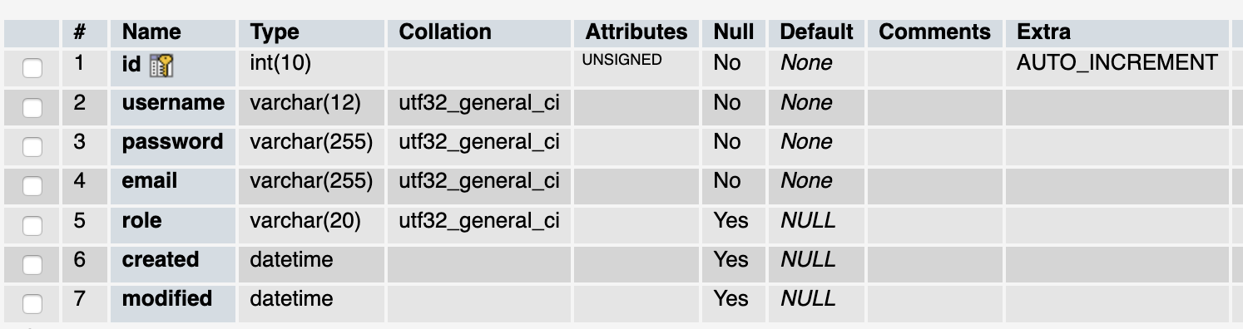

*Note: In CakePHP, the convention requires that every table’s name to be plural.

1. We are now going to use bake to generate skeleton code for our database. Open up a command prompt and change to your cakephp’s app directory.

1. Run the following command:

C:\wamp64\www\my_app_name\bin>cake bake

This should display list of available bake commands. If you do not get the list, maybe you are not in the correct directory.

1. In order to generate skeleton code for our projects, we need to bake Model, Controller and View in sequence. We will start by baking our model. Type the following command:

cake bake model users

when prompt with name of available model, choose one. It will then generate the model file for us.

1. Next is to generate code for controller.

cake bake controller

1. Finally, bake the view.

cake bake template

1. To verify open up the following URL:

http://localhost/my_app_name\users

You should get page that allows you to add/edit/delete users.   
Well Done!

GITHUB

1. As an exercise, you are required to push the above codes to your github account.

1. Download SourceTree from:

https://www.sourcetreeapp.com/

1. Configure so that you can connect to your github account.

1. Create a new repository and add the code generated earlier.